HOLIDAYS’ HOMEWORK
CLASS – VI
Holidays are Fun!!!
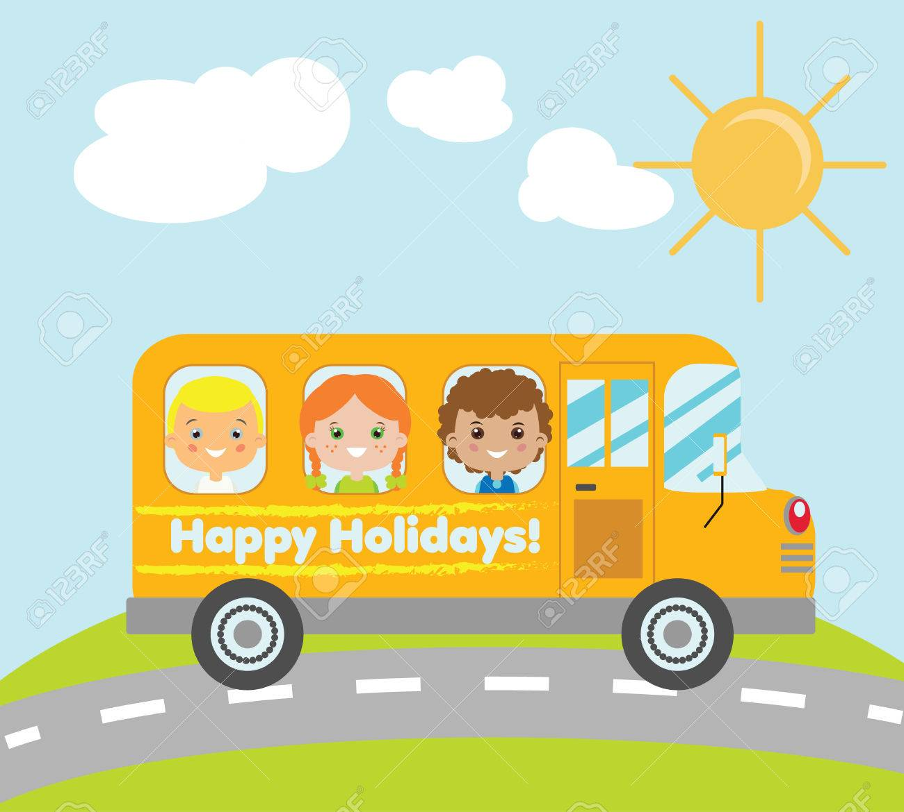
With Projects, Activities and Academics under the Summer Sun……
General Instructions:
- All the students have to do the Academic Homework and Art Integrated/skill based
- homework in their notebooks in neat and legible handwriting.
- OPEN DAY PROJECT: In the table given below roll nos. are written in front of each subject.
- Students(as per given roll nos.) have to submit the Open Day Project work for that subject only.

subject | Roll.no
SCIENCE | 1-8
HINDI | 9-16
MATHEMATICS | 17-24
ENGLISH | 25-32
SOCIAL STUDIES | 33-40
SANSKRIT | 41-48
INFORMATION TECHNOLOGY | 49-54
"Summer is the time to learn something new, explore something fun, and grow a little more."
Academic
ENGLISH
*Do the following work in your English Literature notebook.*
1. Do the competency based questions of the following lessons from the assignment:
*Rama to the rescue (Pg 15)
*The friend's prayer (Pg 24)
*Unlikely best friends (Pg 20)
2. Using the clues given below and write an interesting story in about 150–200 words. Give a suitable title and moral to it.
An old lady – suddenly became blind – called a doctor – agreed to pay large fees if cured – doctor came daily – started stealing one piece of furniture daily – delayed the cure – at last cured her – demands his fees – lady refuses to pay – says eyesight not completely cured – doctor objected – lady argues her sight is not completely cured as she cannot see all her furniture – doctor ashamed
3. Revise the given portion for Periodic Test I.
हिंदी
- शैक्षणिक कार्य
असाइनमेंट में से अप्रैल – मई के अपठित गद्यांश, व्याकरण संबंधित प्रश्न- उत्तर, पाठ्य पुस्तक प्रश्नोत्तर तथा लेखन भाग को A -4 आकार की शीट पर करें |( पृष्ठ संख्या 85 से 97 तक)
➢ व्याकरण पाठ्य पुस्तक से पर्यायवाची शब्द 1 से 15 तक विलोम शब्द 1 से 15 तक, अनेक शब्दों के लिए एक शब्द 1 से 15 तक, अशुद्धि – शोधन 1 से 15 तक मुहावरे 1 से 15 तक याद करें।
➢ नोट- आवधिक परीक्षा के लिए कक्षा में करवाए गए पाठ्यक्रम का अभ्यास एवं दोहरान करें|

MATHEMATICS
Assignment – chapter -2
Art Integrated activity - Activity 1and 2 from the assignment to be done in the Activity File.
SOCIAL SCIENCE

GENERAL INSTRUCTIONS
- Read the holiday homework carefully.
- For Roller chart/Wall Magazine use good quality of sheet.
- For Models use waste material and cardboard available at home.
- Assignment work do carefully after reading the NCERT.
- Prepare Portion for Upcoming Periodic Test.

ACADEMIC HOLIDAY HOMEWORK
Assignment pages 263,264,265,266,267,268,269,270,271,272. (Do in assignment only)
Map Book page no.- Pg 7,9,11,13,15,17,19
SCIENCE
Do the following questions in Physics/chemistry notebook.

Q1. Multiple Choice Questions
(i) Science is based on:
a) Guess b) Observation & experiment c) Magic d) Luck
(ii) Which is a scientific tool?
a) Pillow b) Thermometer c) Toy d) Book
(iii) Living things can:
a) Grow b) Not breathe c) Not reproduce d) Not move
(iv) Which of these is non-living?
a) Plant b) Dog c) Rock d) Bird
(v) Plants make food by:
a) Sleeping b) Photosynthesis c) Jumping d) Running
(vi) A scientist mainly:
a) Observes and experiments b) Plays c) Sleeps d) Guesses
(vii) Diversity means:
a) Same things b) Variety c) Nothing d) Few things

Q2. In the following questions, the Assertions (A) and Reason(s) (R) have been put forward. Read both the statements carefully and choose the correct alternative from the following:
(A) Both the Assertion and the Reason are correct and the Reason is the correct explanation of the Assertion.
(B) The Assertion and the Reason are correct but the Reason is not the correct explanation of the Assertion.
(C)Assertion is true but the Reason is false.
(D) The statement of the Assertion is false but the Reason is true.
(E) Both are false.

- Assertion (A): Plants are living things.
Reason (R): Plants can grow and make their own food.
- Assertion (A): Science is based on observation.
Reason (R): Scientists carefully study things around them.

Q3. Short question answers
- What is science?
- Define living things.
- What is diversity?
- Why is observation important?
- Give two examples of non-living things.
Q4. Long questions answers
- Explain how science helps us in daily life with examples.
- Differentiate between living and non-living things.
Q5. Case Based Questions
CASE-1 Ananya and Rahul went to a park for a science activity. They observed many things around them. They saw trees, small plants, birds, butterflies, ants, and dogs. They also noticed benches, swings, and stones.
Ananya observed that plants near sunlight were greener, and Rahul noticed that animals were moving and reacting, while objects like benches and stones did not move. They discussed their observations and tried to group things into living and non-living. Their teacher appreciated them for using scientific thinking like observation and classification.
- Name any four living things seen in the park.
- Name any two non-living things.
- What difference did Rahul notice between living and non-living things?
- Which scientific skill did Ananya and Rahul use?
- What is meant by diversity based on this case?
CASE-2 Reema loves science and is very observant. One day, she saw water droplets on the outside of a cold water bottle kept outside in summer. She was curious and asked her teacher why that happened. Her teacher smiled and explained how water vapor in the air changes into water droplets when it touches something cold. Reema later observed similar droplets forming on the bathroom mirror after a hot shower.She also visited a garden where she saw bees collecting nectar from flowers and birds building nests. Reema noted all these observations in her science journal.
- What scientific quality did Reema show when she asked her teacher about the water droplets?
(b) What is the name of the process that caused water droplets to form on the bottle?
(c) Why did droplets also form on the bathroom mirror after a hot shower?
(d) What did Reema learn by observing bees and birds in the garden?
(e) How does keeping a science journal help Reema?

ART INTEGRATED
Make 3 D poster to tell importance of science with the diagram and write up.
SANSKRIT
- शैक्षणिक कार्य
1 – पाठ 1 से 3 को अभ्यास सहित याद कीजिए।
प्रथमःपाठ:- संस्कृत-वर्णमाला
द्वितीय: पाठः - संस्कृतशब्दबोधः
तृतीय: पाठ: - धातु-परिचयः
2 – अतिरिक्त अभ्यास पुस्तिका पृष्ठ 135 से 141 तक के लघु प्रश्नों को अभ्यास पुस्तिका में ही हल करें तथा दीर्घ प्रश्नों को ए-4 साइज़ की शीट पर हल करें |(Assignment page no .135 to 141)
3 – पाठ्य पुस्तक से शब्दरूप तथा धातुरूप को याद करें |
शब्दरूप- देव, लता , फलम्
धातुरूप- लट्लकार की धातुएँ |
4- घर में पड़ी हुई इस्तेमाल न होने वाली वस्तुओं का प्रयोग करके कोई भी एक सजावटी सामान बनाइए | उस पर संस्कृत सूक्ति को अर्थ सहित लिखिए |
5- 'ओपन डे प्रोजेक्ट' को बनाइए। (प्रदर्शनी के लिए)
IT
- Solve Ch-1,2 assignment in assignment book.

ART EDUCATION
Poster Topic: Green India
Size: A3 Drawing Sheet
Medium: Poster Colours / Crayons / Sketch Pens etc.
Write slogan: "Go Green India"
KAUSHAL BODH
Make a decorative item using Krishoyia (creative handmade materials) and explain the steps involved in making it.
Like mat, doll, table cloth etc.

OPEN DAY PROJECTS
SCIENCE
OPEN DAY PROJECT(Roll No. : 1-8)
TITLE- ELECTRIC VEHICLE CHARGING STATION

Objectives
- To understand how an Electric Vehicle Charging Station works.
- To promote the use of eco-friendly transport.
Innovation:
1. Use of solar panels to generate electricity for charging.
2. Smart charging system with automatic on/off.
REFERENCE : https://www.youtube.com/shorts/1u8eIsgkCYc?si=AKVQOEapW4BxUcXc
हिंदी
- ओपन डे प्रोजेक्ट (Roll No. : 9-16)
सतत विकसित भारत 2047 पर रोलिंग चार्ट बनाइए | (2-3 चार्ट को जोड़कर)

MATHEMATICS
Open day project work(Roll No. : 17-24)
Common Theme : India @ 2047 : Innovation with Values for a Sustainable World
Maths Dept. Theme : Make a model and chart - Eco friendly family budget.: Design a family budget, showing income/ expenses - where you show reduced electricity bill due to use of solar energy, healthy organic food at less cost, less expense on medicines due to healthy lifestyle and so on… thus saving a handsome amount of income.
Using a part of the saving for the needy… showing empathy. Simple living high thinking.

ENGLISH
Open Day Project (Roll No. : 25-32)
Design a working model depicting how AI technology will help learning four skills of language in 2047.
Sample :
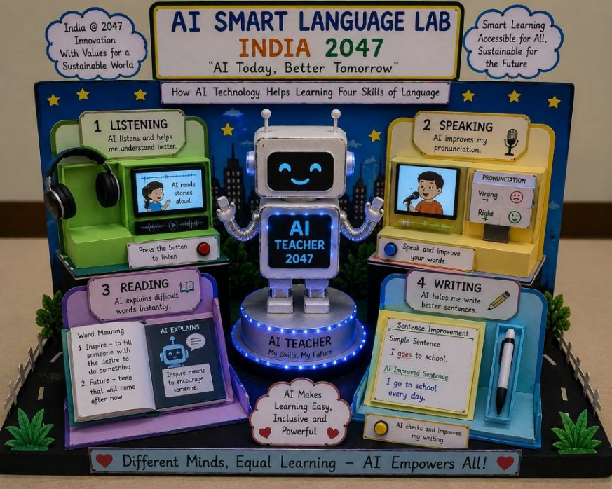

SOCIAL SCIENCE

OPEN DAY PROJECT WORK (Roll No. : 33-40 )

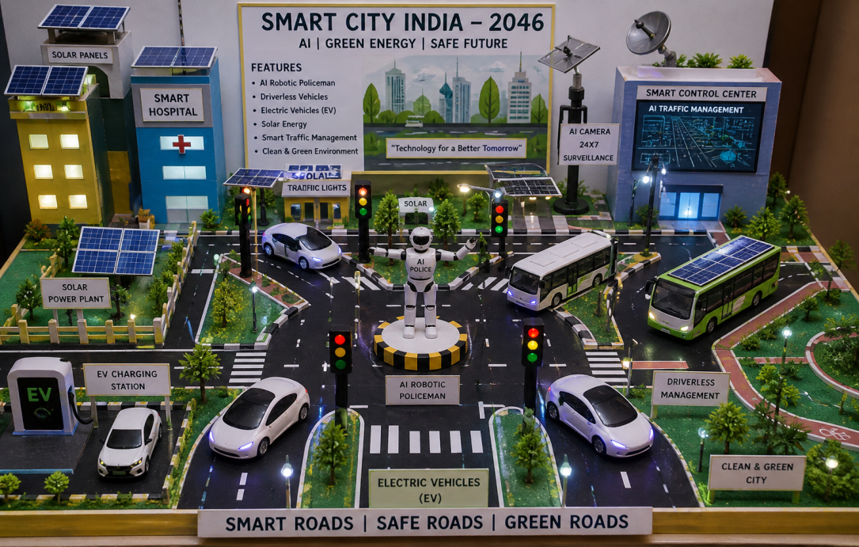
THEME: INDIA@2047-INNOVATION WITH VALUES FOR A SUSTAINABLE DEVELOPMENT
Innovative India @ 2047– Smart City Model
- Create a 3D Working model of a Smart City in India in 2047 that uses advanced technologies such as an AI robotic policeman, driverless cars and buses, charging points, electric vehicles (EV), and solar energy systems. Your model should show how these innovations help in making the city safe, eco-friendly, and efficient.”Make sure model must be working with proper labelling.
- Make a Roller chart to show the advantages of smart city which promotes sustainable development using coloured pictures cutouts and bold headings.
SANSKRIT
“भविष्यकाआदर्शगुरुकुल” (VI A) (Roll No. : 41-48)
एक रोलर चार्ट (2 चार्टजोड़कर) तथा 1 मॉडल बनाइए जिसमें 2047 का विद्यालय दर्शाया जाए|
आधुनिक शिक्षण व्यवस्था (नूतन शिक्षा प्रणाली संस्कृत भाषा से संबंधित)
सौरऊर्जा का उपयोग
संस्कार शिक्षा
तकनीकी साधनों द्वारा अध्ययन
संस्कृत संवाद यंत्र
दर्शाइए कि प्राचीन गुरुकुल परंपरा और नवीन विकास साथ – साथ चल सकते हैं।

स्वच्छभारत : संस्कृतदृष्टिसे (VI B) (Roll No. : 41-48)
एक रोलर चार्ट (2 चार्ट जोड़ कर) तथा एक मॉडल बनाइए जिसमें स्वच्छ भारत का चित्रण हो।
दिखाइए कि लोग अपने घर, विद्यालय, सड़क और जल स्रोतों को स्वच्छ रख रहे हैं। विषय से संबंधित श्लोकों तथा सूक्तियों को अर्थ सहित भी लिखिए|
सूक्ति:
““शरीरमाद्यं खलु धर्मसाधनम्।”
(शरीर ही धर्म का साधन है|)
“स्वच्छता सेवा परमः धर्मः।”
(स्वच्छता श्रेष्ठ सेवा है।)
IT
Open Day Activity(Roll No. : 49-54)
1. Create a wall hanging of IT related applications icons
2. Make a 3 D model of your favourite technological Gadget.

PERIODIC TEST PORTION
ENGLISH
*Literature
Poem - The Raven and The Fox ,A Friend’s Prayer
Lesson- A Bottle of Dew , Rama to the Rescue , The Unlikely Best Friends
*Grammar - The Sentence , Nouns , Articles
*Composition: Paragraph writing , Story writing
*Comprehension Passage
हिंदी
- आवधिक परीक्षा-1 पाठ्यक्रम
पाठ्यपुस्तकसे- मातृभूमि, गोल, पहली बूँद
व्याकरण- भाषा, लिपि, बोली और व्याकरण
वर्ण विचार
शब्दविवेक (1से15तक )
रचनात्मकलेखन - पत्र, अनुच्छेद, अपठितगद्यांश।

MATHEMATICS
Chapter -1- Patterns in Mathematics
Chapter -2- Lines and Angles
SOCIAL SCIENCE

Chapter 1- Locating places on the Earth
Chapter 2- Timeline and sources of history
Chapter-7 India’s Cultural rots
Chapter-9 Family and community
SCIENCE
Ch-1 The wonderful world of science
Ch-2 Diversity in the living world
Ch-4 Exploring Magnets
SANSKRIT
प्रथमःपाठ:- संस्कृत-वर्णमाला
द्वितीय: पाठः – संस्कृतशब्दबोधः
तृतीय: पाठ: - धातु-परिचयः

