Holidays are Fun!!!
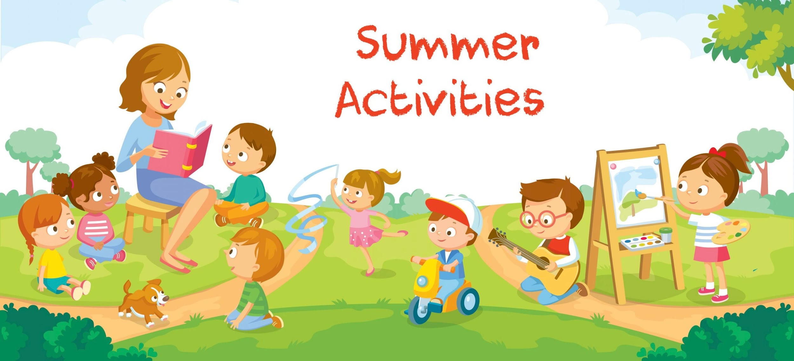
With Projects, Activities and Academics under the Summer Sun……
General Instructions:
- All the students have to do the Academic Homework and Art Integrated/skill based
- homework in their notebooks in neat and legible handwriting.
- OPEN DAY PROJECT: In the table given below roll nos. are written in front of each subject.
- Students(as per given roll nos.) have to submit the Open Day Project work for that subject only.

subject | Roll.no
SCIENCE | 1-8
HINDI | 9-16
MATHS | 17-24
ENGLISH | 25-32
SOCIAL SCIENCE | 33-40
SANSKRIT | 41-48
INFORMATION TECHNOLOGY | 49-54

I.ACADEMIC WORK
ENGLISH
*Do your Holiday Homework in a thin new notebook.
1. Write a short paragraph on the topic ‘Man Proposes God Disposes’.
2. Write a readable story from the given hint
You find a magic button behind your closet door that…....
3. Attempt Competency Based questions of the following chapters:
A. The Day River Spoke - Q2 -Pg -8
B. Try Again -Q1 ,Q2 - Pg -14
C. Three Days to see- Q1,Q2 -Pg 21
4. Revise the given portion for Periodic Test

HINDI
पाठ 3 तीन फूल और कांटा कविता याद करें।
पाठ 4 पानी रे पानी (निबंध) का पठन करे।
असाइनमेंट कार्य :- पेज नंबर 120 से 132 तक के कार्य असाइनमेंट में करें।
असाइनमेंट के प्रश्न उत्तर तथा रचनात्मक लेखन को अलग से पेज पर कर असाइनमेंट पर ही चिपकाएं।

MATHS
Assignment – chapter 1 and -2
Art Integrated activity - Activity 1and 2 from the assignment to be done in the Activity File

SOCIAL SCIENCE
GENERAL INSTRUCTIONS
- Read the holiday homework carefully.
- For Roller chart/Wall Magazine use good quality of sheet.
- For Models use waste material and cardboard available at home.
- Assignment work do carefully after reading the NCERT.
- Prepare Portion for Upcoming Periodic Test.

I. ACADEMIC WORK
Assignment Pg 240,241,242,243,244,245,246,247, 297,298,299,300,301
(Do in assignment only)
Map Book page no. Pg 11,13,15,16,17

SCIENCE
Do the following questions in Physics/ Chemistry notebook
Multiple Choice Questions
1. Which step comes first in scientific method?
a) Experiment​​b) Observation​​c) Conclusion​​d) Result
2. Technology is:
a) Study of starsb) Use of scientific knowledgec) A natural process​d) A type of plant
3. Which of these shows science is evolving?
a) No change in ideasb) New discoveriesc) Old beliefs only​​d) No inventions
4. Scientist is a person who:
a) Plays gamesb) Studies and researchesc) Watches TV​​d) Travels only
5. A solution turns red litmus blue and turmeric red. This solution is:
a) Acidic​​b) Neutral​​c) Basic​d) Salt
6. Which combination will result in a neutral solution?
a) Lemon juice + Vinegar​​b) Soap solution + Baking soda
c) Hydrochloric acid + Sodium hydroxide​d) Curd + Lemon juice
7. A substance does not change the colour of any indicator. It is most likely:
a) Strong acid​​b) Strong base​​c) Neutral substance​d) Salt only
8. Which of the following statements is correct?
a) All acids are dangerous​​​b) All bases are safe
c) Some acids and bases are useful in daily life​d) Neutral substances are harmful
In each of the questions given below, there are two statements marked as Assertion (A) and Reason (R). Mark your answer as per the codes provided below:
(a) Both A and R are true and R is the correct explanation of A.
(b) Both A and R are true but R is not the correct explanation of A.
(c) A is true but R is false.
(d) A is false but R is true.
1. Assertion (A): Soap solution turns red litmus blue.
Reason (R): Soap solution is basic.
2. Assertion (A): Technology depends on science.
Reason (R): Science provides knowledge used in technology.
Short Answer Questions
1. What is the difference between discovery and invention?
2. How do new scientific ideas replace old ones?
3. How has communication changed due to science?
4. Why should acids be handled carefully?
5. Explain how china rose indicator works.
Long Answer Questions
1. Describe different types of indicators and their uses.
2. Explain the neutralisation reaction with an example.
3. Describe the impact of scientific inventions on society
4. Write the importance of neutralisation in daily life.
Case Based Questions
1. A group of students noticed that food kept outside spoils faster in summer than in winter. They formed a hypothesis that temperature affects food spoilage. To test this, they kept food samples at different temperatures and recorded the results.
Questions:
(a) Identify the observation made by the students.
(b) What is the hypothesis in this case?
(c) Describe the experiment conducted.
(d) What conclusion can be drawn from this activity?
(e) Why is it important to repeat experiments?

2. A farmer observes poor crop growth. On testing, the soil is found to be highly acidic. The agricultural expert suggests adding quicklime or slaked lime to the soil.
Questions:
(a) What is the nature of quicklime/slaked lime?
(b) What will happen when it is added to acidic soil?
(c) Name the process involved.
(d) Why is maintaining proper soil pH important?
(e) What would happen if too much base is added?
ART INTEGRATED
Create a colorfulportrait usingacids, bases, and natural indicators.
SANSKRIT
पाठ 1 से 3 को अभ्यास सहित याद कीजिए।
प्रथमः पाठः लट्लृट्लकारयोः पुनरावृत्तिः
द्वितीय: पाठ:- लंगलकारः (प्रथमः पुरुषः)
तृतीय: पाठ- लंगलकारः (मध्यमः पुरुषः)
2 - अतिरिक्त अभ्यास पुस्तिका पृष्ठ 158 से 169 तक के लघु प्रश्नों को अभ्यास पुस्तिका में ही हल करेंतथा दीर्घ प्रश्नों को ए-4 साइज़ की शीट पर हल करें |(Assignment page no .158 से 169)
3 – पाठ्य पुस्तक से शब्द रूप तथा धातु रूप को याद करें |
धातु रूप ( लट्लकार, लृट्लकार, लंगलकार)
शब्द रुप (छात्र, माला, पुस्तक)
4-(i)किसी भी एक जूट बैग पर विद्या से संबंधित श्लोक अर्थ सहित लिखकर सजाइए |
(अनुक्रमांक 1-20 तक)
(ii) किसी भी एक फोल्डर (जिसमे आप ए 4 आकार के महत्त्वपूर्ण कागजों को व्यवस्थित रूप में रख सकें) को बनाकर उस पर मूल्य परक श्लोक लिखकर उसे सजाइए |(अनुक्रमांक 21- 40 तक)
(iii) संस्कृत भाषा में कोई भी एक खेल बनाइए |(अनुक्रमांक 41-55 तक)
5- 'ओपन डे प्रोजेक्ट' को बनाइए। (प्रदर्शनी के लिए)

INFORMATION TECHNOLOGY
Solve Ch-1,2 assignment in assignment book.
​​​​
II. OPEN DAY PROJECT
SCIENCE. (ROLLNO 1-8)
TITLE: SOLAR IRONIC CART
Objective:
1. To demonstrate the use of solar energy for operating an ironing system.
2. To promote the use of renewable and eco-friendly energy sources.
3. To reduce dependence on electricity and fossil fuels.
4. To show the conversion of solar energy into electrical and heat energy.
Innovation:
1. Use of solar panels to generate electricity instead of conventional power sources.
2. Integration of a battery storage system to store energy for use during cloudy weather or evening time.
3. Design of a portable cart with wheels, making it easy to move and use anywhere.
Reference
https://youtu.be/KsHXcJFEgXw?si=LYnNyD7lg3wm6Oci
https://youtu.be/wSf5Lpw4EUc?si=wBXn3i0TPY6fHJud

HINDI (ROLL NO 9-16)
हिंदी के विचार, नवाचार का आधार विषय पर मॉडल बनाएं।

MATHS (ROLL NO 17-24)
Maths Dept. Theme: Innovation with values for a sustainable world
Model Concept: The "Green Corridor" Hub
Build a miniature city "Hub" on a 2x2 foot board that showcases the transition from traditional to green energy.
1. The Physical Components
• The Hydrogen Train (Centrepiece): Use a toy train modified with white and blue colors. Add a small "Fuelling Station" with a mock water tank to represent electrolysis (turning water into hydrogen).
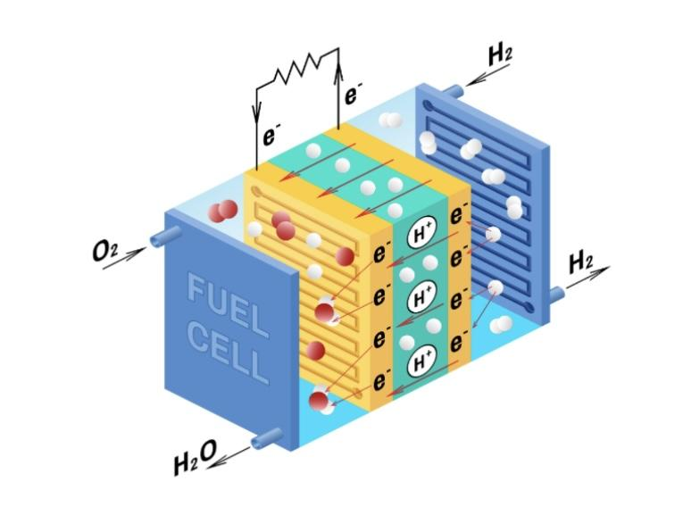
• The EV Bus Lane: Create a dedicated, green-coloured road lane. You can use small toy buses and place "Wireless Charging Pads" (depicted by copper-coloured stickers) on the road surface.
• Active Mobility Zone: A separate, elevated path for Cycles and Walking, separated from the main road by miniature trees or "green belts."
• Renewable Energy Source: Place a few mini wind turbines or a solar panel array at one corner of the board to show where the "Clean Electricity" comes from.
2. The "Maths" Integration (The Data Board)
Place a vertical chart behind your model to show the calculations mentioned in your notes:
Transport Mode | Carbon Footprint (CO2 per km) | Energy Efficiency
Petrol Car | High (~120g) | Low
EV Bus | Zero (Tailpipe) | High
Hydrogen Train | Zero (Tailpipe) | Very High
Cycling/Walking | Zero | Absolute
• Pictograph Idea: Use small "cloud" icons to represent carbon emissions. A petrol car might have 5 clouds, while the EV bus has none.
• Bar Graph: Compare the "Cost of Travel" vs. "Environmental Benefit" for all four modes listed in your notes.

3. The "Values & Sustainability" Section
Incorporate small placards or "speech bubbles" around the model:
• Near the Trees: "Protecting our local flora and fauna."
• Near the EV Station: "Smart grids: Saving electricity for the future."
• Near the Hydrogen Station: "Emitting only water vapor—Clean air for all."
Experimental Element
To make the model "live," can use a simple syringe system to move the Hydrogen Train or use LED strips that light up along the "EV Lane" to show the flow of electricity.
https://gemini.google.com/share/54a9df3d3f00
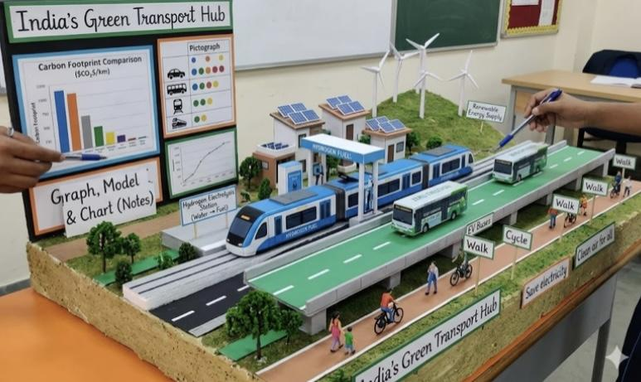

ENGLISH ( ROLL NO 25-32)
Design a working model to demonstrate how India can achieve technological leadership by
2047 through advancements in AI, semiconductors, space tech and defence systems keeping
English language in the central figure through which major communication will be done.
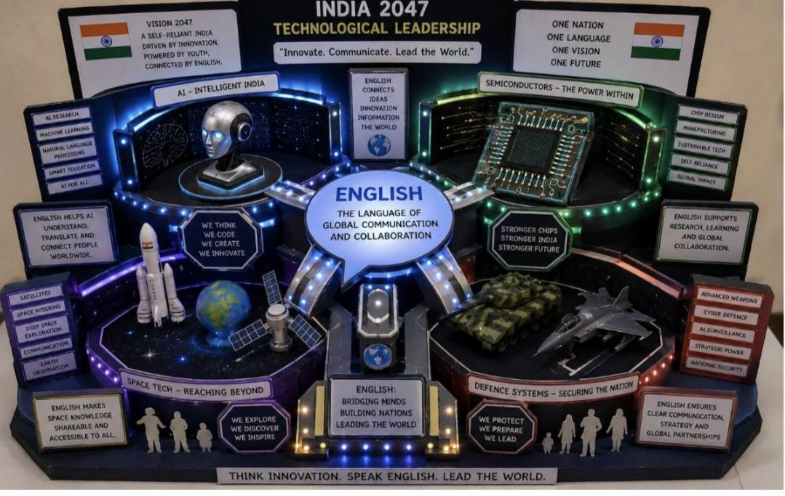
SOCIAL SCIENCE (ROLL NO 33-40)
OPEN DAY PROJECT WORK
THEME: INDIA@2047-INNOVATION WITH VALUES FOR A SUSTAINABLE DEVELOPMENT
“FACEPAY INDIA 2047”


1. “Design and create a working model to show how face recognition technology can be used in
India in 2046 for safe transactions and daily activities. Your model should show how a person’s
face is scanned, verified, and used for payments or accessing services.”
🌟 These followings points can be shown in the model.
• Face scanning system (camera/sensor)
• Verification system (AI/security check)
• 💳 Transaction system (payment/entry/ID check)

• 🚦 Output/result:Access granted / denied
• Payment successful

• 2.Make a Roller chart to show the advantages of facepay method in India which promotes faster and safest development using coloured pictures ,cutouts and bold headings.

REFERENCE LINK:

https://youtube.com/shorts/BKKnl5KiSoc?si=5SjNjPa46rW6r70b

SANSKRIT (ROLL NO 41-48)
वैदिक विज्ञान एवं नवाचार (VII A)
कार्यशील मॉडल तथा रोलर चार्ट ( दो चार्ट जोड़कर) तैयार करें जिसमें—
* प्राचीन भारतीय आविष्कार
* आयुर्वेद​
* खगोल विज्ञान
* योग विज्ञान​
* गणित
* आधुनिक अंतरिक्ष तकनीक से तुलना आदि |

दिखाएँ कि प्राचीन संस्कृत ग्रंथ भविष्य के नवाचारों को कैसे प्रेरित करते हैं साथ ही यह भी दिखाएँ कि ये ज्ञान भविष्य के भारत के विकास में कैसे सहायक हैं।
सूक्ति:
“आ नो भद्राः क्रतवो यन्तु विश्वतः।”

भारतीय कृषि एवं प्रकृति संरक्षण (VII B)
(संस्कृत मूल्यों पर आधारित स्मार्ट सतत गाँव)

भविष्य के भारतीय गाँव का मॉडल तथा रोलर चार्ट (दो चार्ट जोड़कर) बनाइए जिसमें—
* जैविक खेती
* सौर ऊर्जा से चलने वाले घर
* स्वच्छ जल
* गौशाला
* मूल्य आधारित जीवन शैली
मॉडल में उपरोक्त विषयों के साथ-साथ खेत, किसान, वर्षा जल संरक्षण, वृक्षारोपण तथा जैविक खेती को दिखाया जाए। समझाइए कि भविष्य का भारत प्रकृति की रक्षा करते हुए विकास करेगा।

सूक्ति:
“कृषिर्धन्या कृषिर्मेधा कृषिर्जीवनमुच्यते।”
(कृषि ही धन, बुद्धि और जीवन का आधार है।)

“अन्नं बहु कुर्वीत।”
(अधिक अन्न उत्पन्न करो।)

INFORMATION TECHNOLOGY (ROLL NO 49-54)
1. Make a 3 D Model displaying different storage devices –CD, Pen Drive
2. Make a video on theme “Cyber Safety and Threats”

ART EDUCATION
Topic: Best Out of Waste (Pen Stand)
Use old bottles/boxes
Decorate neatly using waste material
Topic: Best Out of Waste (Pen Stand)
Use old bottles/boxes
Decorate neatly using waste mater

KAUSHAL BODH
Prepare natural dyes using vegetables, fruits, spices, and plants. Design pattern for tie and dye and use recycled fabric.
• Steps involved: Natural Dye
• Cut vegetables/fruits/spices.
• Boil in water (10–15 min).
• Cool and strain → dye ready.
👕 Tie and Dye
• Wash old cotton cloth.
• Tie with rubber bands (make patterns).
• Dip in natural dye (20–30 min).
• Dry and open ties → design ready

III. PERIODIC TEST PORTION
ENGLISH
Text Book
1. The Day River Spoke
2. Try Again
3. Three Days To See
*Grammar
The Sentence
Kinds Of Sentence
Verbs
*Writing Skills
Story Writing
*Comprehension Passage
HINDI
पुस्तक : मल्हार
पाठ :- मां कह एक कहानी,
तीन बुद्धिमान
व्याकरण :-
भाषा बोली व्याकरण लिपि,
वर्ण विचार , शब्द विचार
शब्द विवेक ( विलोम, पर्यायवाची, अनेक शब्दों के लिए एक शब्द)
अपठित गद्यांश, काव्यांश, अनुच्छेद, पत्र

MATHS
Chapter 1: Large Numbers Around Us
Chapter 2: Arithmetic Expressions

SOCIAL SCIENCE
Ch 1 Geographical diversity of India
Ch 9 From ruler to rules - types of Government
Ch 7 Gupta Era
Ch 2 Understanding the weather

SCIENCE
Chapter – 1The Ever-Evolving World of Science
​Chapter – 2Exploring Substances – Acidic, Basic, and Neutral
Chapter – 7 Heat Transfer in Nature

SANSKRIT
प्रथमः पाठः लट्लृट्लकारयोः पुनरावृत्तिः
द्वितीय: पाठ:- लंगलकारः (प्रथमः पुरुषः)
तृतीय: पाठ- लंगलकारः (मध्यमः पुरुषः)
शब्द रूप तथा धातु रूप

FRENCH
LEÇON 0 et 1

