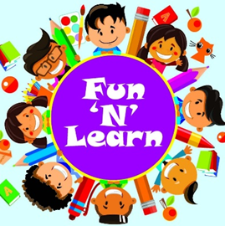

GYAN MANDIR PUBLIC SCHOOL
HOLIDAY HOMEWORK
CLASS: BALVATIKA 1
SESSION- 2026-2027

Dear Parents,
* Summer vacation is not just a break from routine but a wonderful opportunity for children to explore new interests, discover hidden talents and create beautiful memories with their families. Keeping this in mind, we have thoughtfully designed the holiday homework to make learning enjoyable, creative and meaningful.
* The activities and Open Day project work have been planned to promote creativity, curiosity and experiential learning in accordance with the vision of NEP 2020.
* We request you to spend quality time with your wards, guide them, motivate them and help them in completing the activities and project work.
* Kindly supervise your wards while using materials such as scissors, Fevicol , colours and other craft items to ensure safety and proper handling.
* We seek your active involvement and cooperation to make learning more joyful, meaningful and memorable for the children.

ENGLISH
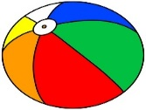
ORAL
- Rhyme- 1. My Ball

2. Two Little Hands

3. Mummy Darling

Recite the rhymes with actions and proper intonation .Use props also .Record a video while reciting each rhyme and send the videos to the Class Teacher.
- Learn 5 sentences on ‘Myself’. (Assignment page no. 8)
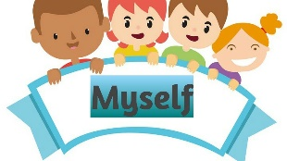
Speak the sentences on ‘Myself’ with proper intonation. Use props also. Record a video while speaking and send it to the Class Teacher.
WRITTEN – Do practice of writing I ,/ , in English Notebook.
HINDI

Oral
- Rhyme- 1. चंदा मामा
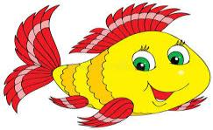
2. मछली रानी

3. समोसा

Recite the rhymes with actions and proper intonation .Use props also .Record a video while reciting each rhyme and send the videos to the Class Teacher.
- Story ‘ दो बिल्लियों और बंदर ‘
Narrate the story with actions and proper intonation .Use props also .Record a video while narrating it and send the video to the Class Teacher.

MATHS
Oral – Revision of Numbers 1 and 7
Written – Do practice of writing Number 1 and 7 in Maths notebook.

EVS
Oral – Revise the following topics-
1.My Body parts
2.Red Colour
3.Yellow colour

PROJECTS. WORK-
THEME: INDIA @2047 INNOVATION WITH VALUES FOR A SUSTAINABLE WORLD

- Make a wall hanging on the topic ‘ Value for India @2047 by using Old CD
- Handprint India @2047 – Trace the kid hand on sheet then on each finger draw or paste pictures of healthy habits, milk ,fruits, play and smiley .Write caption My healthy India @2047.
- Make a poster (A-3 size sheet) on the topic ‘ My Dream India @2047’( Roll no.1 to 17)
- Make a poster ( A-3 size sheet ) on the topic ‘My Dream Home in 2047’ ( Roll no.18 to 34)
- My Future School@ 2047 – Make a Model on ‘ My Future School’ includes smart classroom, green garden ,solar panel by using waste materials ( Roll no.1 to 17).
- My Green India @2047- Make a model on Green India @2047 includes solar panel, Green parks, clean india using waste materials.( 18 to 34)

Note :-
- It is mandatory for all the children to do this project work and submit the exhibits on Wednesday ,1.07.2026 . Assessment will be done for the same and grades will be given.
- Written work must be done in a separate notebook.

